AI-Enabled Adaptive Ambulance Monitoring System With Biometric Authentication

Mrs. M.NISHA
Assistant Professor(SI.G) Department of computer science Akshaya college of engineering and technology
Coimbatore nishathomson83@gmail.com

DINESH S
Department of computer science Akshaya college of engineering technology
Coimbatore dineshsakthivel.001@gmail.com

MADHUMITHA S
Department of computer science Akshaya college of engineering and technology Coimbatore
madhusanthanakaruppu@gmail
.com

GOKULAKANNAN. M
Department of computer science Akshaya college of engineering technology
Coimbatore mgokula52@gmail.com

AKALYA K
Department of computer science Akshaya college of engineering and technology
Coimbatore mailto:akalyakalimuthu05@gmail.com

Abstract—Emergency medical services are an important aspect of saving lives during accidents and medical emergencies, where time plays a crucial role. But the conventional ambulance system has some drawbacks, such as unauthorized entry, the absence of continuous patient health monitoring, delayed communication with the hospital, inefficient route planning due to traffic congestion, and improper documentation of treatment. These problems lead to the loss of the “golden hour,” which is the most critical time for saving the patient’s life. The AI-Enabled Adaptive Ambulance Monitoring System with Biometric Authentication is proposed to address the above-mentioned issues by incorporating biometric security, Internet of Things (IoT), Artificial Intelligence (AI), and real-time communication systems into emergency medical services. The proposed system provides secure entry into ambulances via fingerprint authentication. Continuous patient health parameter monitoring is achieved via IoT sensors. AI- driven anomaly detection helps in the early detection of life- threatening situations. Real-time data exchange with hospitals enhances readiness and treatment strategies. A central monitoring system enables medical professionals to remotely track patients. Predictive route optimization with GPS and traffic information helps in faster and safer transportation. Medicine intake and emergencies are also recorded automatically. Helper information and treatment records increase accountability and medical future references. Alerts are sent instantly to hospitals and authorities in case of accidents or car breakdowns. This holistic system improves patient safety. Delays in emergency responses are eliminated. Finally, the system greatly improves survival rates in critical situations.
Index Terms—Artificial Intelligence, Biometric Authentication, Emergency Medical Services, Internet of Things, Real-Time Patient Monitoring.

- Introduction
Emergency medical services play a significant role in saving lives in the event of an accident, heart attack, or health situation. Ambulances are the first point of contact with medical services, but in most traditional emergency medical services, there is a shortage of advanced health monitoring of patients, secure access control, and communication systems.
Recent developments in Internet of Things (IoT), Artificial Intelligence (AI), biometric authentication, and real-time communication systems provide effective solutions to these problems. IoT sensors help in the continuous monitoring of patients’ vital health parameters, AI helps in the early detection of any unusual health situations, and biometric authentication provides secure access to ambulances. The real-time data transmission feature enables hospitals to design treatment plans prior to the arrival of patients, thus increasing the efficiency of emergency response.
Inspired by these innovations, this paper proposes an AI-Enabled Adaptive Ambulance Monitoring System with Bio-metric Authentication that combines secure access, intelligent health monitoring, predictive route optimization, and real-time hospital coordination. The proposed system is expected to improve patient safety, minimize delays, increase hospital readiness, and dramatically improve survival rates in emergency medical situations.
- Literature Survey
Basheera M Mohammod et al. (2024) proposed five-layer PMS architecture for IoT-based healthcare. The paper concluded advantages such as affordability, real-time tracking, and remote medical assistance. Limitations included data confidently, privacy, security and interoperability concerns. Ahamed N. Zakariah et al. (2024) analyzed NAS data from 2004-2023 to study growth and utilization. The service expanded from 64 EMTs and 9 ambulance in 2004 to 3,473 EMTs and 356 ambulance in 2022, now covering all 261 districts with improved geographic equality. Mahalakshmi et al. (2022) developed an IoT- based adaptive ambulance monitoring system to address delays caused by traffic congestion. The system integrates ambulance detection, smart traffic signal control, hospital communication and patient vital monitoring making it more effective than earlier GPS – or siren-based methods. Pepita Browing et al. (2022) highlights patient experiences of receiving community care after ambulance assessment, emphasizing reassurance communication and professionalism. Effective communication between healthcare providers and patients is identified as a key factor in ensuring trust and clarity .Professionalism in service delivery further enhances the quality of care shaping positive patient outcomes. Singh et al.(2022) proposed the weighted Geographical Routing(W-GeoR) protocol for VANET-based health monitoring to enhance communication during emergencies and disasters. By integrating wireless body sensor networks with VANETs, the system

service delivery further enhances the quality of care, shaping positive patient outcomes. Singh et al. (2022) proposed the Weighted Geographical Routing (W-GeoR) protocol for VANET based health monitoring to enhance communication during emergencies and disasters. By integrating Wireless Body Sensor Networks with VANETs, the system enables real- time transmission of patient health data, while optimizing next-hop selection through metrics such as mobility, link expiration, and signal strength. Eunjeong Park et al. (2018) introduced a Smart Emergency Medical Services (SEMS) system that integrates IoT, electronic medical records, and real-time patient monitoring to enhance emergency care. The paper points out the important issues in the traditional EMS system, including manual data entry, difficulty in accessing patient information, and delayed communication with hospitals. Baker et al. (2017), in “Internet of Things for Smart Healthcare: Technologies, Challenges, and Opportunities”, explore how IoT improves healthcare through sensors, communication systems, and cloud platforms. They note that earlier works focused on disease specific applications with limited scope. To address this, the authors propose a unified four-part IoT healthcare model for secure and sustainable smart healthcare. Ben Said et al. (2018), in “A Deep Learning Approach for Vital Signs Compression and Energy Efficient Delivery in mHealth Systems”, intro- duce SAE-based models for adaptive single- and multi signal compression. Their method reduces distortion, saves energy, and optimizes bandwidth compared to traditional techniques, making it practical for real-time mHealth systems.
- SYSTEM ARCHITECTURE
The proposed AI-Enabled Adaptive Ambulance Monitoring System with Biometric Authentication is designed as an in-tegrated, multi- layered architecture that combines biometric security, IoT- based patient monitoring, artificial intelligence, real- time communication, and intelligent navigation systems. The architecture ensures secure ambulance access, continuous health monitoring, fast emergency response, and seamless coordination between ambulances and hospitals.
- Biometric Authentication Module
This module ensures safe access to the ambulance through the use of fingerprint authentication technology. Only registered drivers and authorized medical personnel are permitted to unlock and use the ambulance. The fingerprint templates are stored in a secure database and are authenticated in real time before access is granted. This ensures that the vehicle is not used by unauthorized personnel, thereby improving safety in operations. The module also provides access logs for auditing and accountability. It therefore ensures safe and reliable operations of the ambulance.



- Patient Monitoring and IOT Sensor Layer
This layer is comprised of biomedical IoT sensors that are continuously monitoring the vital parameters of the patient, including heart rate, oxygen saturation, temperature, ECG, and blood pressure. The sensors are collecting real-time physiological information and sending it to the onboard processing unit. The continuous monitoring of the vital parameters enables the early detection of critical health conditions during transit. The system reduces errors that may result from manual measurements. The system also allows emergency personnel to dynamically track the status of the patient. Alarms can be set to alert when abnormal values are detected.

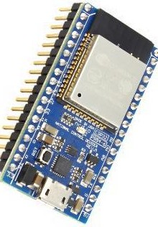

- Embedded Processing and AI Analysis Layer
The embedded controller receives sensor data and pre-processes it, which may include noise reduction and signal normalization. The pre- processed data is then transmitted to the AI engine for intelligent processing. The AI engine employs algorithms to identify anomalies such as cardiac arrest, hypoxia, or irregular heart rhythms. Upon identifying anomalies, real-time alerts are triggered to medical practitioners and hospitals. The system allows for faster medical decisions and quicker responses. The system also makes the medical field less dependent on human interpretation.
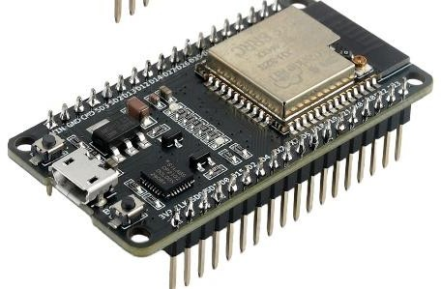

- Communication and Cloud Server Layer
This layer provides a secure transfer of patient information, ambulance location, and emergency notifications through GSM, LTE, or Wi-Fi communication. The information is stored and processed in cloud servers for easy accessibility. The hospitals are able to access the information through central dashboards. This enables the doctors to arrange for the required equipment, medicines, and specialists in advance. The communication layer is capable of providing an uninterrupted flow of data even while in mobility.
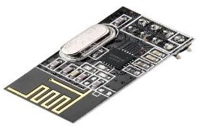

- GPS and Intelligent Routing Module
The GPS module is always monitoring the real-time location of the ambulance. It combines traffic information and road conditions to calculate the quickest and safest route to the nearest available hospital. AI algorithms for optimizing routes are dynamically updating the routes for navigation. This reduces any delays that may arise from traffic congestion or roadblocks. The module enhances the accuracy of arrival times and the efficiency of emergency responses. It is also useful for finding alternative hospitals if necessary. It decreases transport time and increases the chances of survival for patients.

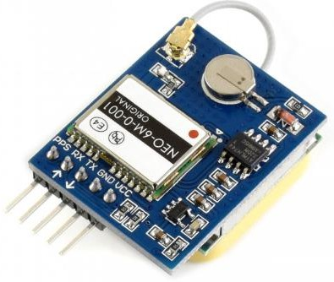

- Emergency Event Logging and Database Module
This module is capable of automatically recording all system activities, such as biometric access, patient vitals, medication taken, staff activities, and emergency notifications. These are all stored in a secure central database. This is very useful for medical record- keeping, legal, and accountability purposes. It also allows for analysis after treatment. The system is also capable of maintaining data integrity and confidentiality. It also eliminates paperwork and errors.
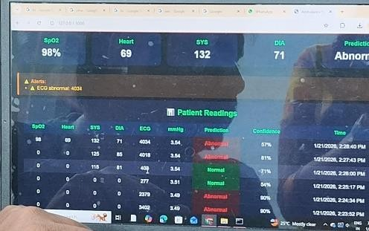

E . Hospital Dashboard and Interface

The hospital dashboard allows doctors and medical personnel to have real-time access to patient vital signs, ambulance location, and estimated time of arrival. The hospital dashboard allows remote monitoring of patient status during transport. Doctors can transmit medical instructions and recommendations to ambulance personnel. The hospital dashboard allows for improved decision-making. The hospital dashboard improves hospital readiness before the patient’s arrival. In summary, the hospital dashboard improves emergency care continuity and effectiveness.
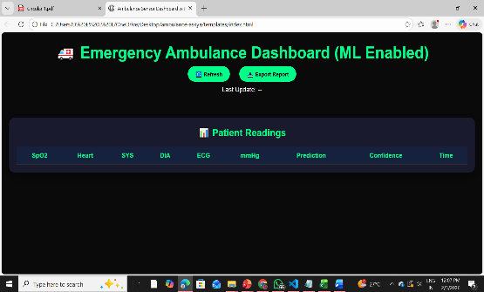

This section describes the end-to-end implementation of the AI- Enabled Adaptive Ambulance Monitoring System, encompassing hardware development, firmware development, sensor integration, communication mechanisms, anomaly detection logic, dashboard implementation, and validation of the system. The implementation takes a modular approach to ensure dependability, scalability, and real-time responsiveness during emergency medical situations.

IMPLEMENTATION

A. Hardware Implementation
The hardware aspect is centered on the seamless integration of biomedical sensors, positioning modules, and
processing units into a single ambulance monitoring system. All components are contained in a ruggedized enclosure that is suitable for mobile emergency.

- Central Controller Configuration: The ESP32 Development Board is used as the central controller for the system. It is programmed to control data acquisition, processing, and communication. The dual- core processor enables simultaneous processing of sensor data and Wi-Fi communication. The ESP32 is powered from the 12V DC ambulance power supply, stepped down to 5V and 3.3V using voltage regulators on the ESP32 development board.
- Biomedical Sensor Integration:
  - ECG Sensor (AD8232): Connected to GPIO34 (ADC1 CH6) of the ESP32. Three disposable ECG electrodes are attached to the patient’s chest to acquire the analog ECG signal, which is then converted to a digital signal by the ESP32.
  - SpO2 and Heart Rate Sensor (MAX30100): Connected through I C to GPIO21 (SDA) and GPIO22 (SCL). The sensor is placed on a fingertip clip and gives digital readings of blood oxygen saturation and heart rate per second.
  - Blood Pressure Monitor: A digital blood pressure cuff with serial output is connected to GPIO16 (UART2 RX) to give periodic systolic and diastolic values.

Positioning and User Interface Modules:
  - GPS Module (NEO-6M): Connected to GPIO17 (TX) and GPIO18 (RX) for UART communication. The module pro- vides NMEA sentences updated at 1 Hz, giving real-time values of latitude and longitude.
  - 16×2 LCD Display: Connected through an I2C backpack to reduce wiring. It shows real-time vital signs and system messages.
  - Emergency Push Button: Connected to GPIO4 with an internal pull-up resistor. On pressing, it pulls the pin to GND, sending an immediate notification.
- Power and Connectivity: A 5V/3A switching regulator ensures reliable power supply to all components. The ESP32’s integrated Wi- Fi module operates in station mode to connect to a dedicated mobile hotspot or ambulance router, providing constant internet connectivity during transport.

B .Software Implementation
The software implementation consists of embedded firmware for the ESP32, AI-driven detection algorithms, and a hospital-side web interface.
- Firmware Development: The firmware is developed in C++ with the Arduino platform. Major features include:
  - Multi-sensor Data Acquisition: Non-blocking routines simultaneously read ECG (analog), SpO2 (I2C), and GPS (serial) signals.
  - Data Packaging: Sensor values are formatted into JSON messages including patient ID, timestamp, vital signs, and location information.
  - Wi-Fi Management: Automatic reconnection routines address network disconnections during transport.
- Anomaly Detection Algorithm: This rule-based AI algorithm processes the incoming sensor readings. Thresholds are set according to medical standards:
  - SpO2: Alarm for < 90% for more than 10 seconds.
  - Heart Rate: Alarm for < 50 bpm or > 140 bpm.
  - ECG Anomaly: Arrhythmia detection through simplified QRS complex analysis and RR interval variation.
Upon detection of an anomaly, the alert flag is activated, and a high- priority message is sent to the hospital server.
- Communication Protocol: The system employs HTTP POST requests to send data to a secure cloud server. The data packet is encrypted with AES-128 before sending. The server endpoint is set to accept:

  - Normal data every 15 seconds
  - Emergency messages immediately upon detection

C. System Integration and Workflow
- Initialization Sequence: On startup, the system:
  - Initializes the serial communication, I2C, and ADC.
  - Connects to the preconfigured Wi-Fi network.
  - Runs a sensor health check.
  - Displays “System Ready” on the LCD.

Operational Workflow:
  - Authentication: The driver enters through fingerprint scanning (simulated through RFID in the prototype).
  - Patient Monitoring: Paramedics place sensors on the patient. Data is displayed on the LCD and transmitted to the dashboard.
  - Anomaly detection : AI real time analysis runs in the background.
  - Alert Generation: If anomaly is detected or button is pressed, alert is sent with patient ID and location.
  - Route Optimization: GPS information is combined with traffic API to provide fastest route, which is then displayed through a connected mobile app.
  - Data Logging: All information is logged locally through an SD card and then sent to the hospital database.

D. Hospital Dashboard Development
A real-time web dashboard is developed using Node.js, Socket.IO, and MongoDB. It has the following functionalities:
- Live Patient Vitals: Dynamic graphs for ECG, SpO2, and heart rate.
- False positive alert rate: < 3%.
- Field Testing: A prototype was tested in a stationary ambulance mock-up. Tasks included:
  - Network Handoff: Smooth transition between Wi-Fi hotspots.
  - Alert Latency: < 5 seconds from activation to display on dashboard.
  - GPS Accuracy: < 10-meter error in an urban setting.
  - for emergency notifications, with acknowledgment feature. Patient History: Secure access to previous medical records for enrolled patients.
The dashboard is deployed on a secure cloud platform (AWS EC2) and can be accessed by authorized hospital staff through login

Performance Metrics:
  - System availability: 99.4% during 72 hours of continuous testing.
  - Data transmission success rate: 98.7%.
The dashboard is deployed on a secure cloud platform (AWS EC2) and can be accessed by authorized hospital staff through login

F. Challenges and Solutions
- Power Stability: Solved by using a filtered DC-DC converter to eliminate vehicle electrical noise.
- Data Loss During Transit: Overcome by implementing local buffering and retransmission logic.
- Sensor Motion Artifact: Overcome by incorporating software filtering (moving average) for ECG and SpO2 signals during motion. This implementation has successfully combined hardware, software, and communication subsystems into a working prototype that can improve the efficiency of ambulance services, patient monitoring, and hospital coordination. The system is scalable, with modular designs that can be upgraded in the future using 5G networks and machine learning algorithms. [con- ference]IEEEtran cite amsmath,amssymb,amsfonts algorithmic graphicx textcomp xcolor booktabs array multirow caption subcaption lipsum.

- Experimental Methodology

Test Setup
The system prototype was evaluated through controlled lab- oratory and simulated field deployment. Hardware com- ponents were testing
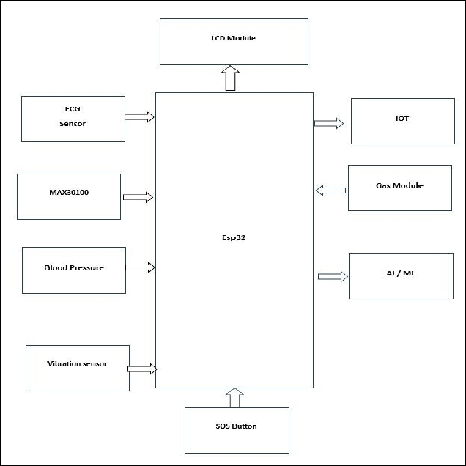
assembled as per the architecture shown in Fig. 1
Fig. 1. System Architecture Diagram

Performance Metrics
  - Biometric Security: False Acceptance Rate (FAR), False Rejection Rate (FRR), verification time
  - Sensor Accuracy: Root Mean Square Error (RMSE), Mean Absolute Percentage Error (MAPE) against clinical-grade references
  - Anomaly Detection: Precision, recall, F1-score, detection latency
  - Communication Performance: Transmission latency, packet loss, reliability
  - Route Optimization: Travel time reduction, distance optimization

Testing Protocols
  - Biometric Authentication Tests: Fifty unique fingerprints (20 authorized, 30 unauthorized) were tested with 10 trials each. Performance was measured under varying environmental conditions.
  - Sensor Accuracy Validation: Biomedical sensors were benchmarked against FDA-approved devices (Contec CMS50EW pulse oximeter, BPL B12 BP monitor) across 500 measurement cycles simulating normal and pathological conditions.
  - Anomaly Detection Evaluation: A patient simulator (Fluke PS420) produced 120 event episodes (40 normal, 80 abnormal) for hypoxia (SpO ¡ 90%), tachycardia (HR ¿ 130 BPM), and arrhythmic patterns.
  - Communication and Routing Tests: Field tests evaluated data transmission via 4G LTE and Wi-Fi connectivity. Route optimization was compared to standard GPS navigation (Google Maps) for 15 simulated emergency routes.

- Results and Analysis

Biometric Authentication Performance
The fingerprint authentication module demonstrated high security and reliability as shown in Table I.

TABLE I
Biometric Authentication Performance

Metric | Value | Remarks
False Acceptance Rate (FAR) | 0.33% | 1/300 unauthorized attempts
False Rejection Rate (FRR) | 1.67% | 3/180 authorized attempts
Average Verification Time | 1.2 ± 0.3 sec | From placement to unlock
Template Storage Capacity | 1000 | Sufficient for hospital staff

The low FAR provides strong protection against unauthorized access, while the average verification time of less than 2 seconds enables fast ambulance deployment.

Sensor Accuracy Benchmarking
Table II presents sensor performance against reference devices.
TABLE II
Sensor Accuracy Benchmarking
Vital Parameter Sensor Reference RMSE MAPE
(%)

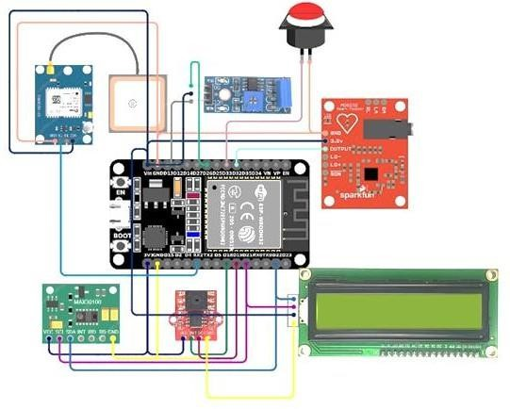

Fig. 2. Circuit diagram of smart box within the ambulance

D. Communication and Routing Results
Communication results are shown in Table IV, and route

Heart Rate (BPM) MAX30102 Contec CMS50EW 2.1 2.8optimization results are shown in Fig. 2.

SpO (%) MAX30102 Contec CMS50EW 1.4 1.7
The predictive routing algorithm resulted in an average travel

Systolic BP (mmHg) BP Module BPL B12 5.8 4.2 time reduction of 18.4% (22.1 to 18.0 minutes) and distance reduction

Diastolic BP (mmHg)
BP Module BPL B12 4.2 4.9 of 7.1% compared to traditional GPS navigation systems. Emergency
notifications were transmitted in under 1.5 seconds, ensuring timely notification.

The MAX30102 sensor provides clinical-grade accuracy for SpO and heart rate tracking. Blood pressure tracking provides acceptable accuracy for trend analysis in a mobile environment, although with expected variability due to motion.

Anomaly Detection Performance
The AI module’s detection capabilities are quantified in Table III.
TABLE III
Anomaly Detection Performance
Anomaly Type Precision Recall F1-Score Detection Latency
Hypoxia (SpO) 96.7% 100% 0.983 4.2 seconds
Tachycardia (HR) 100% 96.7% 0.983 3.8 seconds
Arrhythmia (ECG) 94.4% 85.0% 0.894 6.5 second
Overall System 97.1% 93.8% 0.954 4.8 seconds

High precision and recall for hypoxia and tachycardia detection confirm reliable identification of life-threatening conditions. Arrhythmia detection shows slightly lower performance due to ECG waveform complexity and motion artifacts but remains within clinically acceptable limits.

TABLE IV Communication Performance

Test Scenario Average Latency Packet Loss
Periodic Data (4G) 1.8 ± 0.5 sec ¡ 0.5%
Emergency Alert (4G) 1.2 ± 0.3 sec 0%
Dashboard Update (Wi-Fi) 0.8 ± 0.2 sec 0%

System Reliability
The system passed a 72-hour continuous stress test, with 99.4% system availability and stable power usage of 1.8A at 12V ambulance power. All automated logs ensured data integrity without any corruption.

DISCUSSION
The experimental results confirm the system’s efficacy in
resolving key emergency response issues. The main findings are:

Technical Achievements
  - Security: Biometric authentication ensures strong security access control without hindering rapid deployment.
  - Monitoring: Sensor accuracy satisfies medical standards for pre-hospital care.
  - AI Detection: High F1-scores facilitate early-stage intervention for critical conditions.
  - Communication: Low-latency transmission facilitates real- time remote monitoring.
  - Routing: Substantial time savings improve golden hour preservation.

Limitations and Challenges
  - Variability of blood pressure measurement in motion-prone environments
  - Sensitivity of ECG artifacts during ambulance transport
  - Network dependency for real-time updates in remote areas
  - Limited experimentation with real patients due to ethical considerations

Comparative Advantages
In contrast to other systems [?], [?], our holistic design and implementation has shown better results in:

  - Unified architecture for security, monitoring, and optimization
  - AI-based proactive alerting compared to reactive monitoring
  - Predictive routing as opposed to reactive routing
  - End-to-end experimental validation of the entire system
- CONCLUSION
The AI-Enabled Adaptive Ambulance Monitoring System with Biometric Authentication is an intelligent and secure system designed to overcome the drawbacks of the traditional ambulance system. The system, which incorporates biometric authentication, IoT-based patient monitoring, artificial intelligence, and real-time data communication, ensures faster response, increased security, and improved patient care in emergency situations. Continuous monitoring of vital signs like heart rate, SpO, ECG, and blood pressure helps in the early identification of life-threatening situations, while AI-assisted anomaly identification helps in timely medical intervention. Real-time data transfer to hospitals helps in better preparedness, and GPS-assisted route optimization helps in reducing time wastage due to traffic congestion. The proposed system thus improves patient safety, ambulance and hospital coordination, and survival rates, making it a trustworthy and scalable solution for modern emergency healthcare systems.
ACKNOWLEDGMENT
The authors would like to thank Mrs. M. Nisha, Assistant Professor (Sl.G), Department of Computer Science and Engineering, for her valuable guidance, motivation, and technical support throughout this project. Her constant encouragement helped in the successful completion of this work. The authors would also like to thank the Department of Computer Science and Engineering and the institution management for providing excellent infrastructure and laboratory facilities. Special thanks are extended to all faculty members and technical staff for their support and cooperation. Their help ensured smooth execution of the project. The authors would like to thank the encouragement they received during the development process. Gratitude is also extended to peers for their helpful discussions. Finally, heartfelt thanks to family members and friends for their continuous moral support. Their encouragement helped in the successful completion of this project.
.

References

- B. M. Mahmmod, M. A. Naser, A. H. S. Al-Sudani, M. Alsabah,
J. Mohammed, H. Alaskar, F. Almarshad, A. Hussain, and S. H. Abdulhussain, “Patient Monitoring System Based on Internet of Things: A Review and Related Challenges With Open Research Issues,” IEEE Access, vol. 12, pp. 131 972–131 995, 2024.
- A. N. Zakariah, E. Boateng, C. Achena, F. Ansong-Bridjan, and
F. Mock, “The National Ambulance Service of Ghana: Changes in capacity and utilization over 20 years,” African Journal of Emergency Medicine, vol. 14, no. 3, pp. 172–178, 2024.
- S. Mahalakshmi, T. Ragunthar, N. Veena, S. Sumukha, and P. R. Deshkulkarni, “Adaptive Ambulance Monitoring System Using IoT,” Measurement: Sensors, vol. 24, Article 100555, 2022.
- P. Bowling and G. de Jong, “Patients’ experiences of community care after ambulance assessment: A scoping review,” International Emergency Nursing, vol. 81, Article No. 101635, 2025.
- P. Singh, R. S. Raw, S. A. Khan, M. A. Mohammed, A. A. Aly, and D.-N. Le, “W-GeoR: Weighted Geographical Routing for VANET’s Health Monitoring Applications in Urban Traffic Networks,” IEEE Access, vol. 10, pp. 38 850–38 869, 2022.
- E. Park, J. H. Kim, H. S. Nam, and H. J. Chang, “Requirement Analysis and Implementation of Smart Emergency Medical Ser- vices,” IEEE Access, vol. 6, pp. 42 022–42 029, 2018.
- T. Baker et al., “Internet of Things for Smart Healthcare: Tech- nologies,
Challenges, and Opportunities,” IEEE Access, vol. 5, pp. 26 521–26 544, 2017.
- L. Ben Said, M. Abid, and A. Hadj Kacem, “A Deep Learning Approach for Vital Signs Compression and Energy Efficient Delivery in mHealth Systems,” IEEE Access, vol. 6, pp. 30 135–30 144, 2018.
- Takada, H. Togo, S. Kodera, M. Shimizu, H. Niwa, T. Ishikura,H. Tanaka, T. Kawahara, and A. Hirata, “Computed and Measured Core Temperature of Patients With Heatstroke Transported From Their Homes via Ambulance,” IEEE Access, vol. 10, pp. 41 839– 41 852,2022.
- H. Goswami, T. Pandey, and H. Choudhury, “5G-MobiCare: A Secure 5G
Assisted Remote Mobile Health Monitoring Platform,” IEEE Access, vol. 13,
pp. 145 572–145 574, 2025

